Attorney Guide to Civil Case Opening

Background
Online case opening allows cases to be filed 24 hours a day, 7 days a week and eliminates the delay caused by emailing the complaint and civil cover sheet to the Clerk’s Office.
A NextGen CM/ECF filing account is required in order to open a new case. Please see https://ksd.uscourts.gov/cmecf or contact the Clerk’s Office for instructions on how to file your complaint. If you are not an attorney and are filing your case pro se, please contact the clerk’s office for instructions.
Kansas City: 913-735-2200 ksd_clerks_kansascity@ksd.uscourts.gov
Topeka: 785-338-5400 ksd_clerks_topeka@ksd.uscourts.gov
Wichita: 316-315-4200 ksd_clerks_wichita@ksd.uscourts.gov

Opening Your Civil Case (Statistical Input)
Step | Action
1 | Login to Kansas NextGen CM/ECF using your PACER credentials.
2 | Select Civil from the menu bar.
3 | Select KSD Open a New Case.  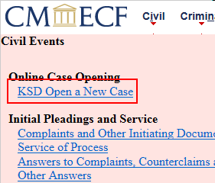
4 | Review the announcements from the court. The announcements may change at any time, so please be sure that you review them with every filing. Click Next  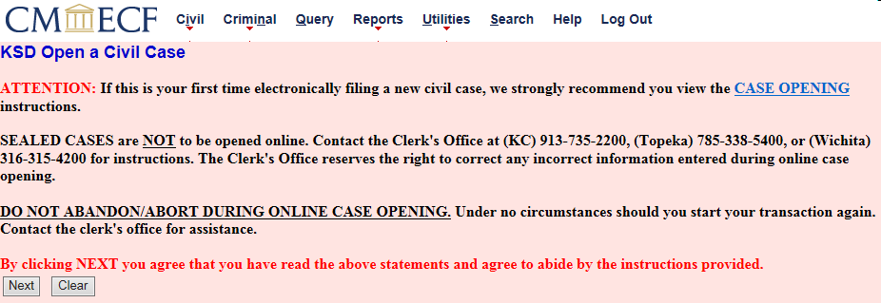
5 | Respond to each of the prompts. Information entered will cause the system to assign the case to the appropriate divisional office. This information should match the information that is included on your civil cover sheet. You will receive a case number at the end of the transaction, but judges will not be assigned until the case has been reviewed by the clerk’s office. After the case has been reviewed, the clerk’s office will enter a Notice of Judge Assignment to notify you which judges will hear the case.  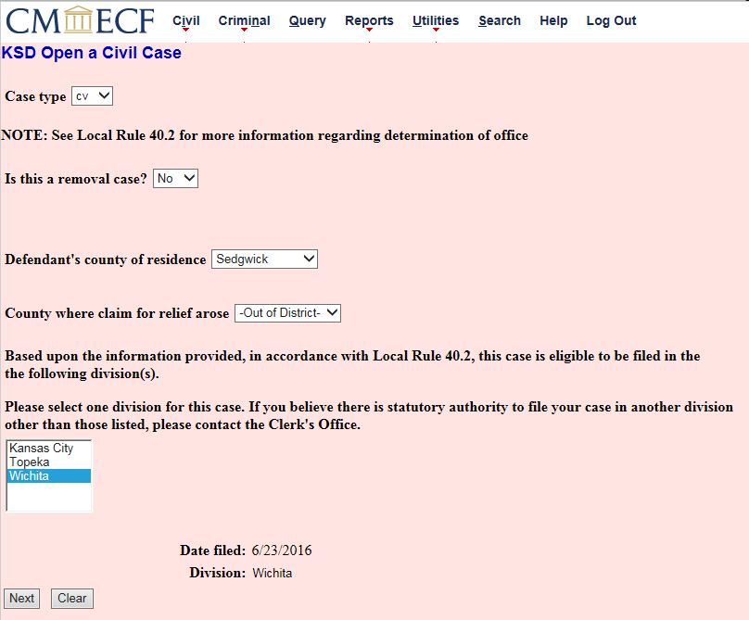  Data elements for this screen:  Case Type:  If you are filing a… Then select…  Complaint, Notice of Removal or Petition for Writ of Habeas Corpus cv as the Case Type  Any other documents mc as the Case Type (see Miscellaneous Case Opening instructions, beginning on page 13)
Is this a removal case?
If you are filing an original petition, select No.
If you are removing this action from a state district court, select Yes. If you select Yes, several elements of the screen will change and you will be prompted to enter the name of the original court and the case number:
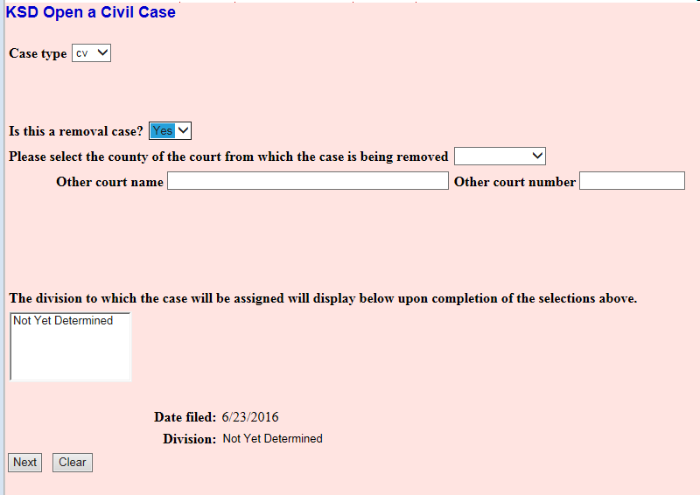
Defendant’s county of residence:
Select the defendant’s county of residence. If there are multiple defendants and at least two of the defendants reside in different counties, select the county in which one or more of the defendants reside.
County where claim for relief arose:
Select the appropriate county.
Selecting the proper divisional office:
The system will display the division(s) are eligible to hear your case. You must select the same division that was named on your designation of place of trial. Click on the appropriate division. Click Next.
Please note that you are still required to include a designation of place of trial within your complaint, or, if you choose to file it as a separate document, you should file it immediately after filing your complaint.
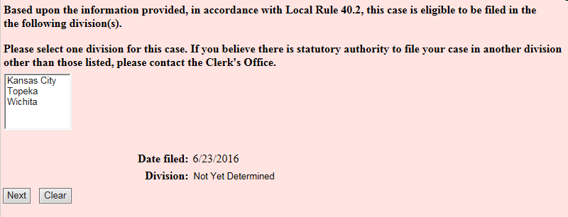
6 | Statistical Information Screen  All of the information on this screen comes directly from the civil cover sheet. The civil cover sheet should also be filed immediately after filing the complaint using the Civil Cover Sheet event; it should not be attached to the complaint entry.  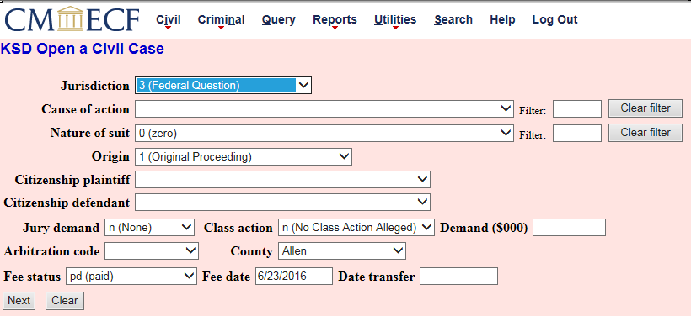  Data elements on this screen –  Jurisdiction:  Select the appropriate jurisdiction. The field defaults to Federal Question, but the drop down list displays additional options, including Diversity, U.S. Government Plaintiff and U.S. Government Defendant.
Cause of Action:
Select the appropriate cause of action. The statutes are listed in numerical order. Use the drop down list to find the appropriate statute, or enter the full or partial statute in the Filter field. CM/ECF will narrow down the drop down list to the items that match the string entered.
Nature of Suit:
Select the appropriate nature of suit. Click the drop down list and scroll down to find the appropriate entry or enter the full or partial nature of suit in the Filter field to further narrow down the drop down list to the items that match the string entered.
Origin:
Use the drop down box to select the appropriate origin. A complaint originating in the Federal Court is always 1 (Original Proceeding). A notice of removal is always 2 (Removal from State Court).
Citizenship:
Select the appropriate citizenship statement for the parties. Note: Diversity must be selected on the Jurisdiction field if you are completing the citizenship fields.
Jury Demand:
If your initiating document contains a jury demand, select the appropriate response. The jury demand can be made by the plaintiff when filing a complaint or the defendant when filing a notice of removal. N (none) should be selected if the document filed does not explicitly state a jury demand.
Class Action:
If you are alleging a class action in your initiating document, click the drop down box and select “y”. To request class certification, you must file a motion once your case has been opened.
Demand ($000):
Enter monetary demand from the initiating document. The demand should be entered to the nearest thousand dollars. For example, if you are requesting $1,500,000 enter 1500, without a dollar sign, comma or decimal. The amount will display as $1,500,000 on the docket sheet.
Arbitration:
Leave blank. The Arbitration code field is not used in the District of Kansas.
County (of first plaintiff):
Select the county of residence/business for the first plaintiff listed in the case. If the county of the first named plaintiff is outside the District of Kansas, select XX US, Outside State or XX Outside US from the drop down list.
Fee Status:
Unless you are a U.S. government agency or you are filing in forma pauperis, the fee status should be set to pd (paid). If a motion to proceed in forma pauperis is being filed, fp (in forma pauperis) should be selected. Attorneys for the United States or agencies of the United States government should select the fee status waived.
Fee Date:
The fee date defaults to the current date. Do not change or remove the date.
Date Transfer:
Leave blank. The date transfer field is not used.
7 | Party Name Entry  The most critical piece of online case opening is the entry of party names. It is important that this be done correctly since it impacts not only your case, but the records of the court. The Party Entry Guide is available on our website to assist you in adding parties. We suggest you print it or save it for future reference.  The attorney search screen is divided into two panels. The left panel contains buttons labeled Add New Party and Create Case. The search fields in the right panel allow users to search the CM/ECF database for parties.  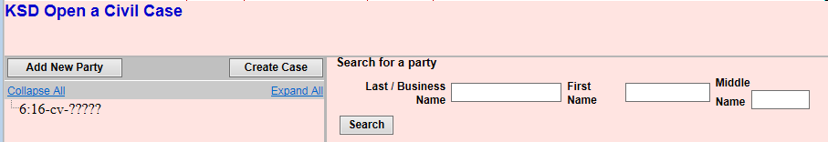
Searching for a Party:
Search the names that are already in the CM/ECF database by entering at least three letters of the party’s last name in the last name field. If your party is a corporation, enter the first three letters of the corporate name in the last name field. The Party Entry Guide includes search hints to help you search the CM/ECF database for parties.
If the system finds a match, CM/ECF will display a list of party names. Scroll through the list. If you find something similar, check your own spelling or configuration to determine which is preferable.
If the name of the party you represent appears in the list, select it and then click Select Party.
Creating a New Party:
If you do not find a match, click Create New Party to create a new party in the database. CM/ECF will display the Party Information screen to collect information regarding the new party.

Only the following information should be added/selected:
- Last name;
- First name;
- Middle name (if applicable);
- Generation (if applicable);
- Role; and
- Party text (if applicable)

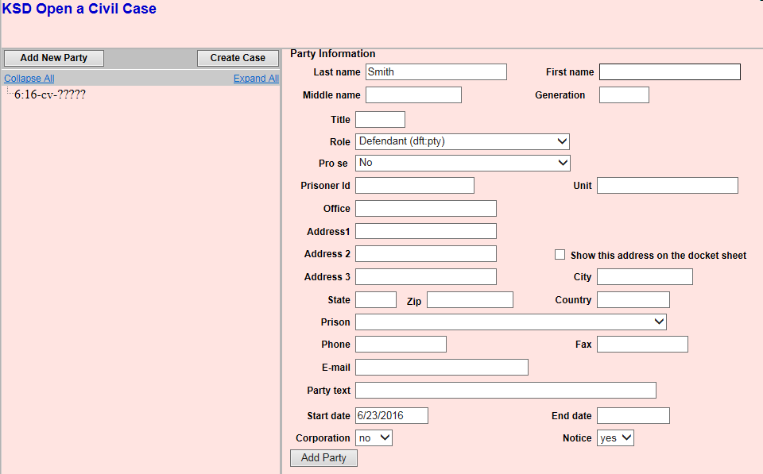

Do not enter any additional information on this screen. The remaining fields should be left blank.
Party Name:
For business names, enter the entire name in the last name field. For individuals, use both the first and last name fields. If entering the name of a minor child, use only the first letter of the child’s first and last name, and enter the initials in the appropriate first or last name fields.
Role:
Select the appropriate role from the list. The list defaults to defendant.
Party Text:
This field is optional. It allows you to add descriptive information about the party that you have included in the caption of the complaint. Examples of such text include “a Kansas corporation” or “individually and in his/her official capacity.”
 | After the required information has been added, click Add Party.
8 | Reviewing the Parties  The Case Participant Tree  As the parties are added, they will appear in the left panel. This panel is called the Case Participant Tree.  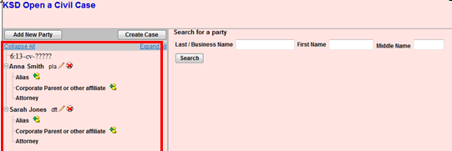  The following chart provides you with a description of the icons and hyperlinks you see in the left panel of the Case Participant Tree.  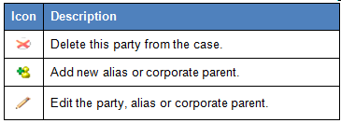  The Expand all hyperlink displays all parties, including aliases, corporate parents and attorneys. The Collapse all hyperlink displays only the parties in the case, with all other information collapsed in the tree.  Each branch of the Case Participant Tree can be expanded or collapsed individually by clicking on the + and – icons.  If the tree is not expanded, you should expand it to make sure you have all parties and aliases added. If necessary, click the appropriate icon in the Case Participant Tree to add or correct information.
9 | When all parties have been added and appear correctly in the Case Participant Tree, click Create Case.
10 | You have one final opportunity to make changes before opening the case. If you click No, you will return to the Add New Party screen. If you click Yes, the case will be created and a case number will be issued.  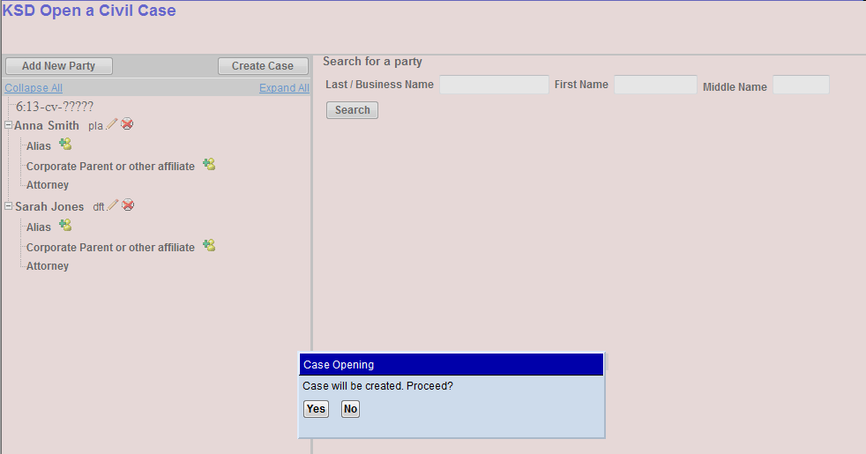
11 | Note the case number and click Docket Lead Event  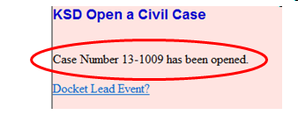
12 | Select the appropriate Lead Event from the list. Each of the events will prompt for the payment of the filing fee, when necessary.

Order of Documents to be Filed
The case initiating documents should be filed in the following order:
- Complaint or Notice of Removal (if filing a Notice of Removal, the original state court petition must be attached to the Notice of Removal)
- Civil Cover Sheet
- Designation of Place of Trial (if not included in the initiating document)
- Motion to proceed in forma pauperis (if appropriate) (please attach the Affidavit of Financial Status to the motion)
- AO 120 or AO 121 (as appropriate) if you are filing a case involving a patent, trademark or copyright. These forms are available on the court’s website.

Assignment of Judge
Your case is considered open when you receive the Notice of Electronic Filing for the initiating document. The Clerk’s Office will review all information entered during case opening and make any necessary corrections. Judges will be assigned and the Clerk’s Office will file a Notice of Judge Assignment. If the clerk’s office finds deficiencies in the filing, a Notice of Deficiency will be filed, directing counsel to correct the deficiencies as soon as possible. Notices of Deficiency will be entered after the judges have been assigned so that the judges’ chambers are aware of any deficiencies in the filings.

Miscellaneous Case Opening

What Qualifies as a Miscellaneous Case?
Miscellaneous cases are generally administrative in nature and are ancillary or supplementary proceedings that are not considered civil or criminal cases, though, they may be related to a civil or criminal case that is pending in another district.
Examples of miscellaneous cases include:
- Application to Enter Premises
- Letters Rogatory
- Motion to Enforce or Quash IRS Summons
- Motion to Enforce or Quash Subpoena
- Motion to Perpetuate Testimony
- Motion to Vacate or Enforce Arbitration Award
- Motion to Withdraw Reference to Bankruptcy Court
- Notification of Appointment of Receiver (Receivership)
- Registration of Judgment From Another District (or Bankruptcy Court)

A NextGen CM/ECF filing account is required in order to open a new case. Please see https://ksd.uscourts.gov/cmecf or contact the Clerk’s Office for instructions on how to file your complaint.

Kansas City: 913-735-2200 ksd_clerks_kansascity@ksd.uscourts.gov
Topeka: 785-338-5400 ksd_clerks_topeka@ksd.uscourts.gov
Wichita: 316-315-4200 ksd_clerks_wichita@ksd.uscourts.gov

Opening Your Miscellaneous Case (Statistical Input)

Step | Action
1 | Login to Kansas NextGen CM/ECF using your PACER credentials.
2 | Select Civil from the menu bar.
3 | Select KSD Open a New Case.
4 | Review the announcements from the court. The announcements may change at any time, so please be sure that you review them with every filing. Click Next
5 | Respond to each of the prompts. Information entered will cause the system to assign the case to the appropriate divisional office. This information should match the information that is included on your civil cover sheet. You will receive a case number at the end of the transaction, but judges will not be assigned until the case has been reviewed by the clerk’s office. After the case has been reviewed, the clerk’s office will enter a Notice of Judge Assignment to notify you which judges will hear the case.  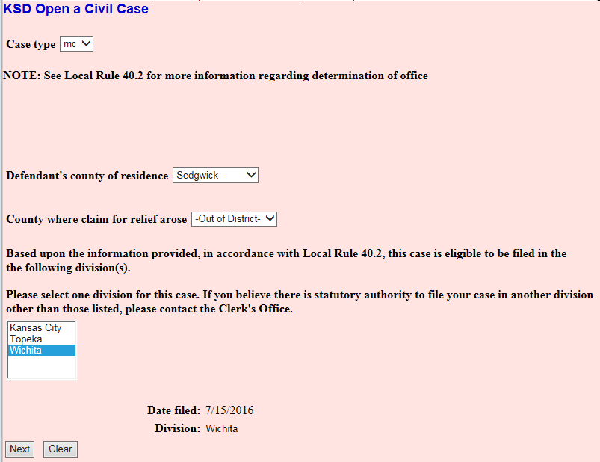
6 | Party Name Entry  The most critical piece of online case opening is the entry of party names. It is important that this be done correctly since it impacts not only your case, but the records of the court. The Party Entry Guide is available on our website to assist you in adding parties. We suggest you print it or save it for future reference.  The attorney search screen is divided into two panels. The left panel contains buttons labeled Add New Party and Create Case. The search fields in the right panel allow users to search the CM/ECF database for parties.  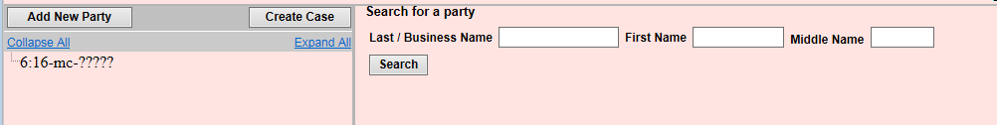
Searching for a Party:
Search the names that are already in the CM/ECF database by entering at least three letters of the party’s last name in the last name field. If your party is a corporation, enter the first three letters of the corporate name in the last name field. The Party Entry Guide includes search hints to help you search the CM/ECF database for parties.
If the system finds a match, CM/ECF will display a list of party names. Scroll through the list. If you find something similar, check your own spelling or configuration to determine which is preferable.
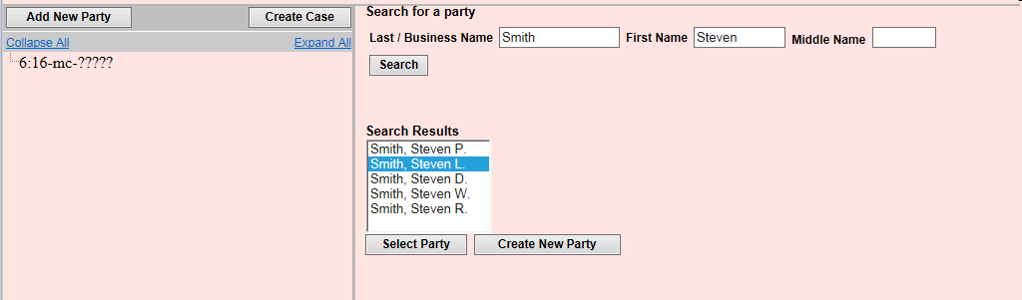
If the name of the party you represent appears in the list, select it and then click Select Party.
Creating a New Party:
If you do not find a match, click Create New Party to create a new party in the database. CM/ECF will display the Party Information screen to collect information regarding the new party.

Only the following information should be added/selected:
- Last name;
- First name;
- Middle name (if applicable);
- Generation (if applicable);
- Role; and
- Party text (if applicable)

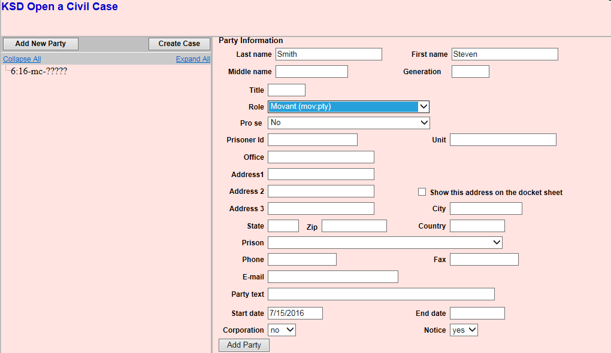

Do not enter any additional information on this screen. The remaining fields should be left blank.
Party Name:
For business names, enter the entire name in the last name field. For individuals, use both the first and last name fields. If entering the name of a minor child, use only the first letter of the child’s first and last name, and enter the initials in the appropriate first or last name fields.
Role:
Select the appropriate role from the list. The list defaults to defendant.
Party Text:
This field is optional. It allows you to add descriptive information about the party that you have included in the caption of the complaint. Examples of such text include “a Kansas corporation” or “individually and in his/her official capacity.”
 | After the required information has been added, click Add Party.
Reviewing the Parties

The Case Participant Tree
As the parties are added, they will appear in the left panel. This panel is called the Case Participant Tree.
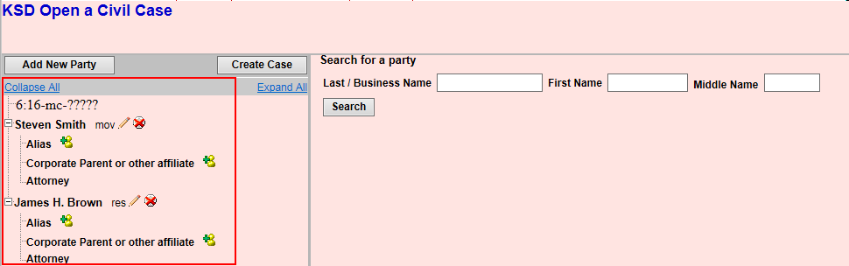
The following chart provides you with a description of the icons and hyperlinks you see in the left panel of the Case Participant Tree.
The Expand all hyperlink displays all parties, including aliases, corporate parents and attorneys. The Collapse all hyperlink displays only the parties in the case, with all other information collapsed in the tree.
Each branch of the Case Participant Tree can be expanded or collapsed individually by clicking on the + and – icons.
If the tree is not expanded, you should expand it to make sure you have all parties and aliases added. If necessary, click the appropriate icon in the Case Participant Tree to add or correct information.
 | When all parties have been added and appear correctly in the Case Participant Tree, click Create Case.
7 | You have one final opportunity to make changes before opening the case. If you click No, you will return to the Add New Party screen. If you click Yes, the case will be created and a case number will be issued.  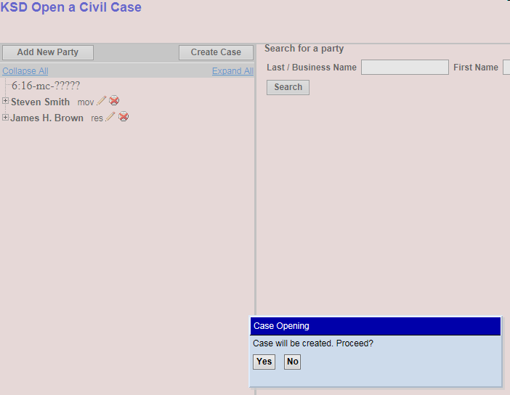
8 | Note the case number and click Docket Lead Event  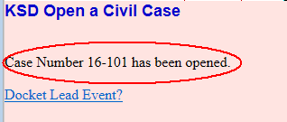
9 | For miscellaneous cases, the lead event should always be Miscellaneous Case initiating Document. You will not be prompted to attach a document to this event. Your first pleading should be filed using the appropriate event AFTER you enter the Miscellaneous Case Initiating Document event.  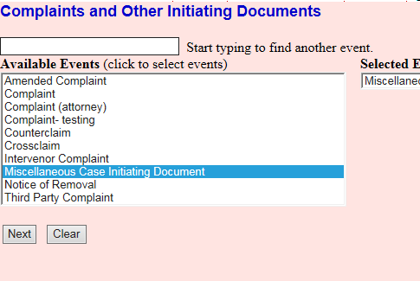
10 | The Miscellaneous Case initiation Document event will prompt you to select the type of miscellaneous action that you are filing from a list of possible actions. If the type of action that you are filing is not on the list, please contact the clerk’s office to verify that you are filing the case correctly.  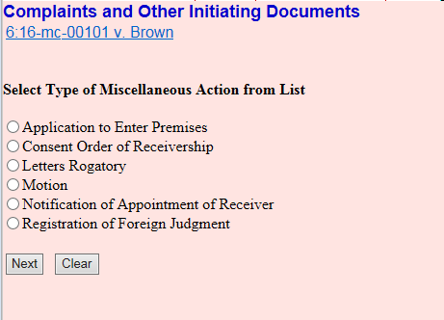  If you indicate that you are filing a motion, you will see the following reminder:  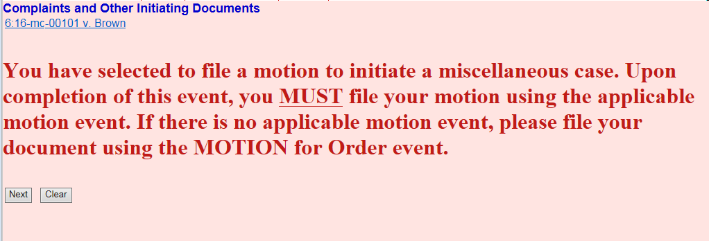  You will be prompted to pay the miscellaneous case filing fee as you proceed through the event.
10 | After completing this event, file your initiating document using an event from the proper category of the CM/ECF menu.

Revision Control Log
Date | Comments | By
7/21/16 | Clarified background section to direct pro se filers to contact the clerk’s office (MG); added info re: attaching state court petition to notice of removal (MG & MAM) and financial affidavit to motion for IFP (MAM); clarified that the civil cover sheet should be a separate entry (MG); corrected misc. typo (MG & MAM); clarified entry of business names (MG); clarified the timing of filing notices of deficiency (MAM) | CS

